**Lab2:** Explain different CLI commands and usage methods.

**1. ls command: List the contents of a folder**

This is among the first few commands a new Linux user learns. This command lets you see what files and folders are in your current folder.

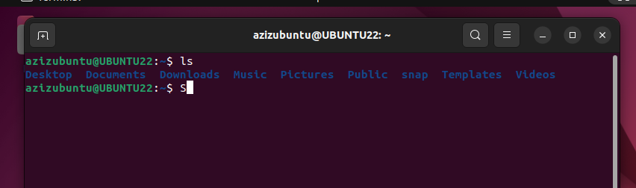

You can use the long listing option ls -l to see details like file size, permission, modified time, etc. You can sort and control these options if you want to.

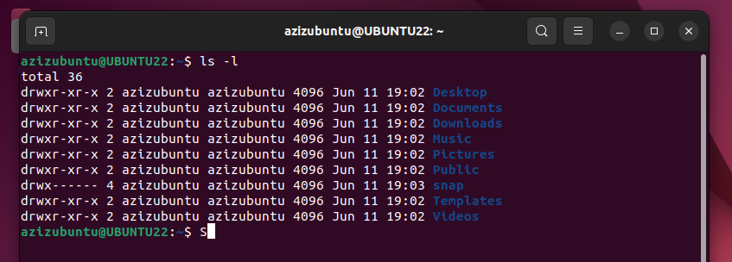

**2. cd command: Change the directory**

By default, you start in your home directory. You’ll often require to change the directory and move to another one.

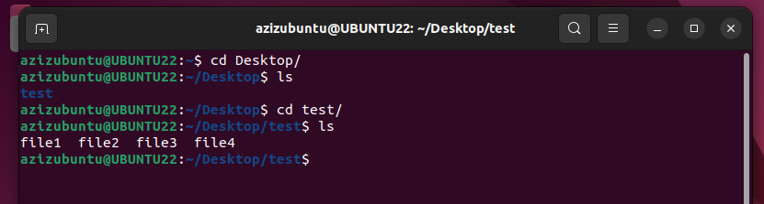

**3. cat command: Read a text file**

If you quickly want to see the contents of a text file in Linux, cat is the command you use. It displays the contents on the screen.

**Syntax:** cat filename : To display content.

Cat > filename: Information can be added to file.

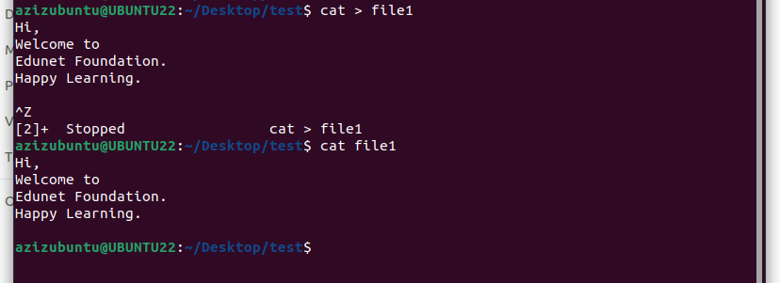



**cat command (to copy file):**

The 'cat' command can be used to copy the content of a file into another file.

**Syntax:** cat (older file name) **>** (newer file name)

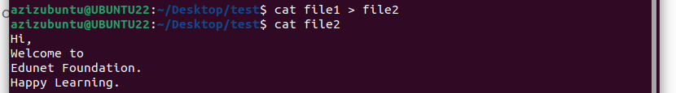



**4 tac command**

The 'tac' command is the reverse of the 'cat' command. It is also known as 'cat' backward. It will display the file content in reverse order. It prints the last line first, then second last and so on. Such way, it prints the first line at last.

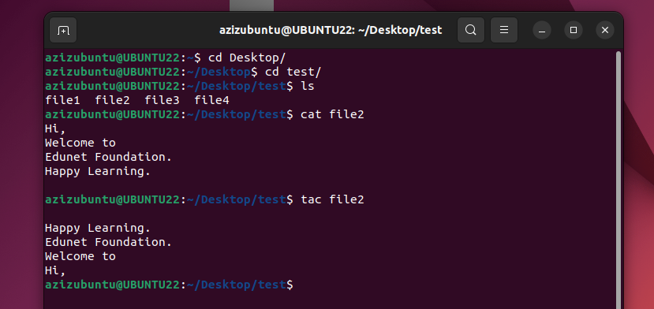



**5. touch command: Create new files**

There are multiple ways of creating new files in the Linux terminal. The cat command you saw above can also create new files.

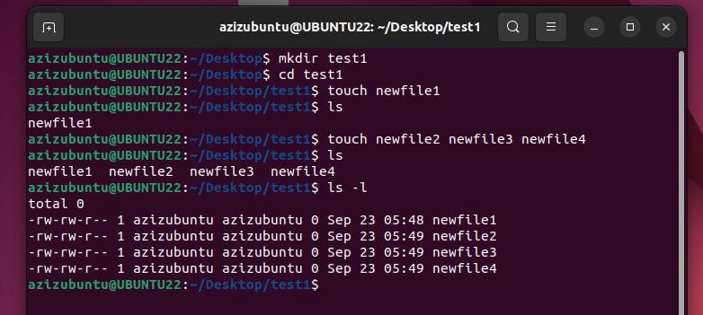



**6. mkdir command: Make new folders**

While there is no specific command for creating new files, there is a dedicated command for making new folders (or directories, as we call them in Linux).

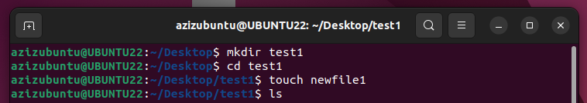



**7. rm command: Remove files and folders**

You use the rm (short for remove) command to delete files in the Linux terminal.

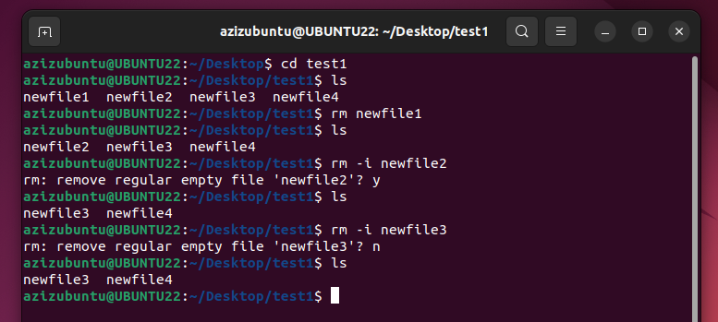



**8. ps: Check and handle processes**

The ps command is for handling the processes running on your system. Each process has an associated ID called PID, which can be used for various purposes, such as terminating a process.

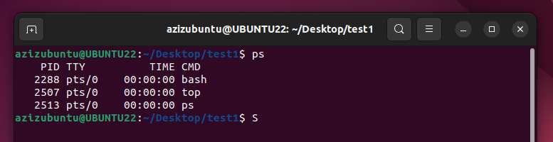



Here,

* PID: Process ID
* TTY: Controlling terminal associated with the process (Not that important these days)



* TIME: Total CPU usage time
* CMD: Name of command that runs the process

But a system cannot run just 2-3 processes, can it? To see all the processes running by all users, use:

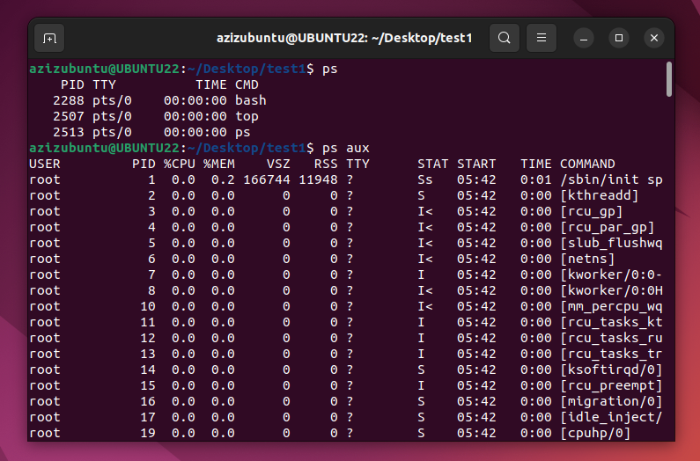



**9. pwd Command**

PWD stands for Print Working Directory. It writes the complete path name of the working directory to standard output in UNIX-like and other operating systems.

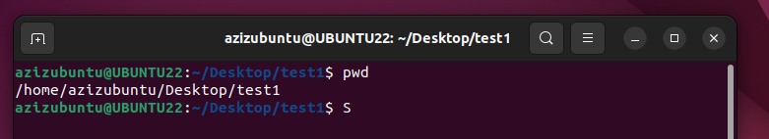



**10. rmdir Command**

This command is used to delete a directory. But will not be able to delete a directory including a sub-directory. It means, a directory has to be empty to be deleted.

